A PROJECT REPORT ON

**Redzon: A Subreddit Analysis and Community Exploration Tool**

Submitted in partial fulfilment of the requirement for the award of the degree of

**MASTER OF COMPUTER APPLICATIONS**

(OMC306 Mini Project, Third Semester MCA)

Submitted by:

**Name:** Deepankar Sharma **Student ID:** 233512013

Under the Guidance of

**Dr. Jayashree Kulkarni**

**Professor,GEU**



**Department of Computer Applications**

**Graphic Era (Deemed to be University)**

**Dehradun, Uttarakhand**

**CANDIDATE'S DECLARATION**

I/we hereby certify that the work which is being presented in the Project Report entitled "**Redzon: A Subreddit Analysis and Community Exploration Tool**" in partial fulfillment of the requirements for the award of the Degree of Master of Computer Applications (OMC306 Mini Project, Third Semester MCA) in the Department of Computer Applications of the Graphic Era (Deemed to be University), Dehradun shall be carried out by the undersigned under the supervision of **Guide Name**, Designation, Department of Computer Applications, Graphic Era (Deemed to be University), Dehradun.

**Name:** Deepankar Sharma

**Student ID:** 233512013

**Signature:**

The above-mentioned student shall be working under the supervision of the undersigned on the "**Redzon: A Subreddit Analysis and Community Exploration Tool**."

Signature Signature

Supervisor Head of the Department

**Internal Evaluation (By DPRC Committee)**

Status of the Project Report: Accepted / Rejected

Any Comments:

Name of the Committee Members:

1.

2.

Signature with Date

**Table of Contents**

1. Introduction and Problem Statement
   1. Introduction
   2. Problem Statement
2. Background/ Literature Survey
3. Objectives
4. Hardware and Software Requirements
   1. Hardware Requirements
   2. Software Requirements
5. Possible Approach/ Algorithms
   1. Data Collection and Preprocessing
   2. Visualization Techniques
   3. Topic and Similarity Analysis
6. Applications and Real-World Impact
7. References

**Chapter 1: Introduction and Problem Statement**

1.1 Introduction

Often referred to as ***"the front page of the internet"***, Reddit serves as a dynamic aggregation point for trending content and diverse discussions. With thousands of active subreddits covering virtually every conceivable topic—from technology and gaming to health and politics—Reddit has solidified its position as a central hub for real-time news, niche communities, and viral phenomena. This expansive platform enables businesses, marketers, and researchers to tap into the collective wisdom of millions of users, providing invaluable insights into audience behavior, preferences, and emerging trends.

However, despite the wealth of information available, many existing tools fail to offer user-friendly interfaces and holistic analyses of subreddit data. This often results in missed opportunities for marketers and content creators who seek to optimize their outreach strategies based on community-driven insights.

The Significance of Reddit

"Redzon" is an innovative, Streamlit-powered application designed to leverage the vast troves of data available on Reddit for actionable insights. Reddit has become a pivotal platform for discussions, information exchange, and community engagement, offering a unique opportunity to tap into diverse datasets. By utilizing Python’s PRAW (Python Reddit API Wrapper) library, Redzon enables users to interact with Reddit's rich subreddit ecosystem effectively. This powerful tool empowers users to analyze community trends, explore similar subreddits, and extract critical information that can optimize strategies for online engagement, search engine optimization (SEO), and content marketing.

Redzon’s Key Features

Redzon bridges the existing gap by offering a suite of features designed to provide meaningful insights into subreddit dynamics:

**Subscriber Growth Analysis:** Users can gain a clear understanding of how a subreddit’s audience evolves over time. This feature allows businesses to monitor the health and growth trajectory of specific communities, informing their engagement strategies.

**Activity Metrics:** The application provides tools to monitor engagement trends, such as post frequencies and comment activity. By analyzing these metrics, users can gauge community interest and participation levels.

**Topic Discovery and Community Exploration:** Redzon facilitates the discovery of new subreddits and allows users to analyze them based on similar topics. This feature helps marketers identify niche communities that align with their target audiences.

**Visualization and Reports:** Redzon generates visual summaries of subreddit performance, enabling users to make data-driven decisions. By presenting insights in an intuitive manner, the tool enhances understanding and supports strategic planning.

1.2 Problem Statement

As social media platforms like Reddit become increasingly critical for content discovery, brand engagement, and SEO, the demand for effective analytical tools has surged. There are several key challenges that users face when trying to utilize Reddit data effectively:

1. **Simplifying Subreddit Data Analysis:** Many users, particularly those who are not technically inclined, struggle with the complexity of existing tools. There is a pressing need for solutions that simplify subreddit data analysis, making it accessible to a broader audience.
2. **Visual and Intuitive Insight Presentation:** Users require tools that present insights visually and intuitively for actionable use. The complexity of raw data often obscures meaningful insights, hindering decision-making processes.
3. **Community Identification for Optimized Reach:** Businesses and content creators must be able to identify relevant communities to optimize their outreach organically. Tools that facilitate the identification of niche communities are crucial for maximizing engagement.
4. **Trend Analysis for Future Activity Prediction:** There is a need for effective trend analyses to predict future activity and identify "rising" subreddits. Understanding emerging trends allows users to stay ahead of the curve and tailor their strategies accordingly.

Existing tools either fall short in usability or lack comprehensive analytics capabilities, making it challenging for users to harness Reddit’s potential for targeted content and community engagement. Redzon addresses these gaps by providing a scalable, interactive, and user-friendly solution that democratizes access to subreddit insights. By equipping users with the tools to analyze and visualize data effectively, Redzon empowers them to make informed decisions and enhance their online presence.

In conclusion, the emergence of Redzon represents a significant advancement in the way users interact with Reddit data. By bridging the gaps left by existing tools, Redzon not only enhances the understanding of community dynamics but also enables businesses and content creators to craft more effective engagement strategies.

Market Description



Subreddit

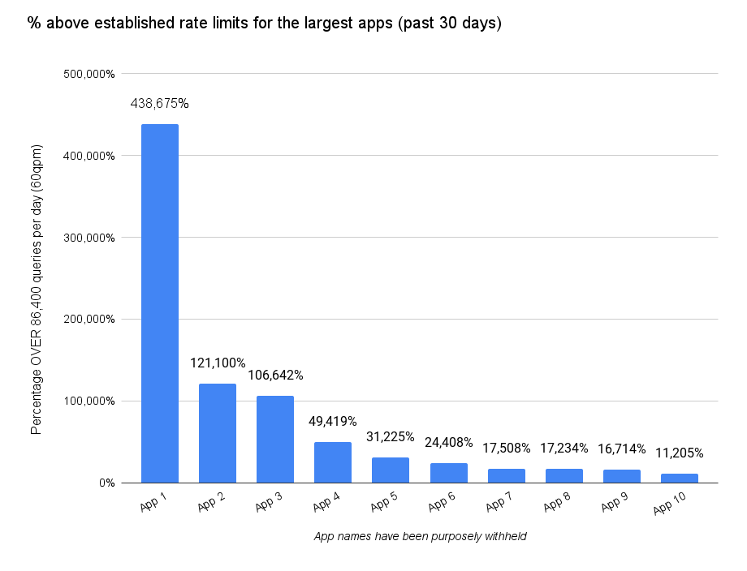

Business Insights



Figure 4: Project Workflow

**Chapter 2: Background/ Literature Survey**

The exponential growth of Reddit as a hub for community-driven discussions has prompted researchers, marketers, and data scientists to explore its potential for deriving audience insights. Since its inception, Reddit has evolved from a simple content-sharing platform to a multifaceted social media site where millions of users engage in discussions across thousands of active subreddits. This transformation has not only changed how information is consumed but has also created an invaluable resource for understanding consumer behavior, preferences, and emerging trends.

2.1 The Role of Reddit in Modern Marketing

2.1.1 Community-Driven Discussions

Reddit’s architecture is built around user-generated content, primarily in the form of posts and comments organized into specific subreddits—dedicated spaces for various topics. Each subreddit operates under its own community guidelines, fostering unique cultures and engagement patterns. This diversity makes Reddit an ideal platform for marketers looking to connect with niche audiences. By understanding community dynamics and user engagement, businesses can tailor their marketing strategies to resonate with specific segments.

2.1.2 Organic Traffic and Influencer Identification

Marketing professionals increasingly rely on Reddit to drive organic traffic to their websites. By participating in subreddit discussions and leveraging user feedback, brands can gauge audience sentiments and preferences. Moreover, Reddit serves as a breeding ground for influencers who often emerge from within communities. Identifying these influencers can enhance brand visibility and credibility, leading to improved marketing outcomes.

2.2 Challenges in Data Interpretation and Visualization

Despite the potential benefits, the vast amount of data available on Reddit presents challenges for effective analysis. Tools like PRAW have simplified the process of accessing Reddit's API, allowing developers to extract data programmatically. However, while raw data access is straightforward, interpreting and visualizing this data remains a significant hurdle. Many users lack the technical expertise required to analyze large datasets, resulting in missed opportunities for actionable insights.

2.2.1 Data Complexity

The complexity of Reddit data arises from its multifaceted structure, which includes posts, comments, user interactions, and subreddit-specific rules. Each data point can contain nuanced information that requires contextual understanding. For example, the sentiment of comments may vary widely depending on the subreddit’s culture, making it difficult to derive clear conclusions from raw metrics alone. Consequently, marketers and researchers often struggle to translate this data into meaningful strategies.

2.2.2 Lack of User-Friendly Tools

Existing tools for Reddit analysis often fall short in usability. Many of them are designed for users with technical backgrounds, making it challenging for non-technical users to harness the platform's insights effectively. This barrier to entry has created a demand for intuitive, user-friendly tools that can simplify data analysis and visualization, enabling a broader audience to leverage Reddit’s potential for marketing and community engagement.

2.3 Opportunities for Analysis

Without proper analysis tools, users miss critical opportunities to:

* **Discover High-Performing Communities:** Marketers need to identify and engage with communities that align with their business goals. Effective analysis tools can help discover subreddits with high engagement levels, allowing brands to position themselves strategically.
* **Identify Trends and Optimize Content Strategies:** Understanding trending topics and user sentiments is crucial for optimizing content strategies for SEO. Marketers can benefit from tools that analyze discussion trends, enabling them to create content that resonates with target audiences.
* **Leverage Data for Community Building and Campaign Planning:** Data-driven insights can facilitate community building and campaign planning by identifying key engagement drivers and areas of opportunity. Insights into community preferences allow marketers to craft targeted campaigns that foster loyalty and encourage user interaction.

2.4 Integration of Insights into Redzon

Recognizing these challenges and opportunities, Redzon has been developed to integrate the requirements for effective subreddit analysis into one cohesive platform. By combining real-time data fetching capabilities with intuitive visualization tools, Redzon ensures seamless access to insights that were previously difficult to attain.

2.4.1 Real-Time Data Analysis

Redzon’s ability to fetch real-time data from Reddit using the PRAW library allows users to stay updated on community trends and dynamics. This feature is crucial for marketers who need to make timely decisions based on current discussions and engagement patterns. Unlike traditional methods that rely on outdated data, Redzon offers a fresh perspective on community activity, enabling users to adapt their strategies dynamically.

2.4.2 User-Friendly Visualization

By prioritizing user experience, Redzon provides intuitive visualization tools that transform complex data into easily digestible insights. The application’s interactive dashboards allow users to explore subreddit metrics visually, facilitating better understanding and decision-making. This user-friendly approach empowers marketers and content creators, regardless of their technical expertise, to leverage Reddit’s data effectively.

2.4.3 Comprehensive Analysis Features

Redzon’s suite of features—such as subscriber growth analysis, activity metrics, and topic discovery—addresses the critical gaps in existing analysis tools. By providing actionable insights through a single platform, Redzon simplifies the analysis process, allowing users to discover high-performing communities, identify trends, and optimize their content strategies for better engagement and SEO performance.

**Chapter 3: Objectives**

The primary aim of the proposed work, "Redzon," is to create a comprehensive and user-friendly tool that facilitates subreddit analysis. The objectives outlined below detail the functionalities and features that will be developed to enhance the user experience and provide valuable insights into community dynamics on Reddit.

3.1 Develop an Interactive Subreddit Analysis Dashboard Using Streamlit

The first objective is to build an interactive dashboard powered by Streamlit, a popular framework for developing web applications in Python. This dashboard will serve as the central hub for users to access various features and insights about subreddits. Key components of this objective include:

**User-Centric Design:** The dashboard will be designed with a focus on usability and aesthetics, ensuring that users can navigate easily and access the information they need without confusion. This will involve intuitive layout design, clear labeling of sections, and responsive features that adapt to user interactions.

**Project Snaps**

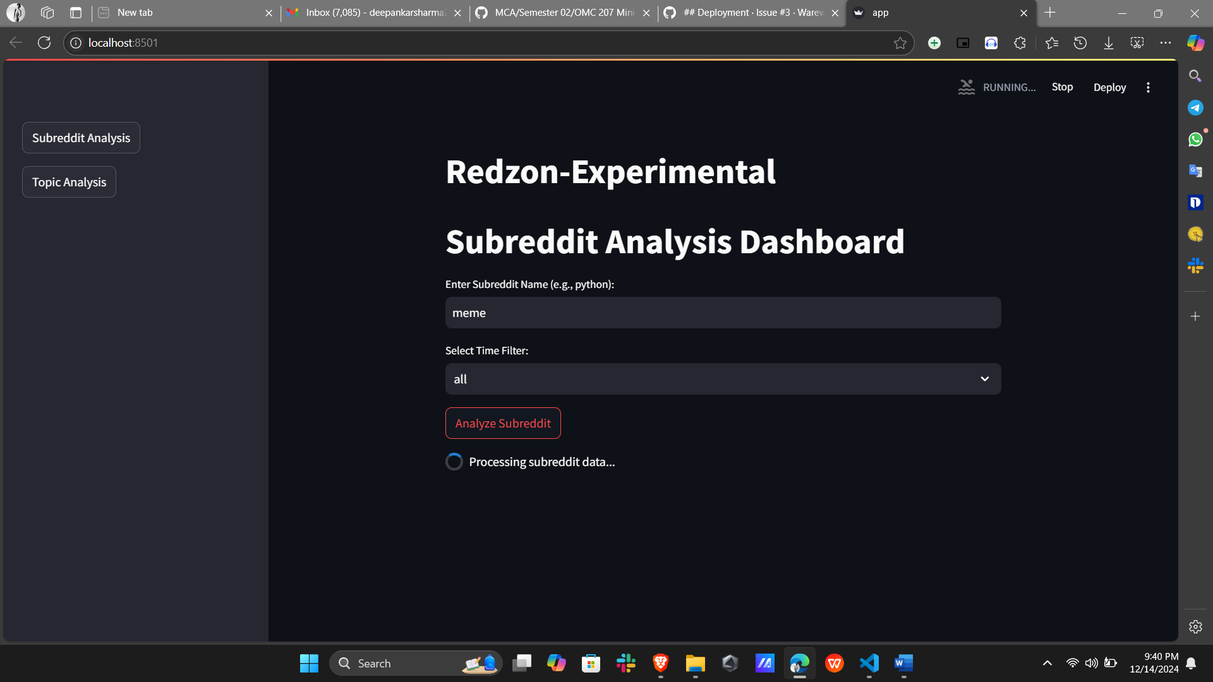

**Dynamic Content Display:** Users will be able to view multiple metrics and analyses on a single screen, such as subscriber counts, post frequencies, and engagement trends. Streamlit’s ability to handle real-time data updates will allow users to see changes instantly as new data is fetched from Reddit.

**Interactivity Features:** Users will have the ability to filter and manipulate data directly from the dashboard. For instance, users can select specific timeframes, subreddits, or topics to generate tailored insights, fostering a more engaging and personalized experience.

3.2 Enable Real-Time Data Fetching from Reddit Using PRAW

The second objective focuses on the integration of the PRAW (Python Reddit API Wrapper) library to enable real-time data fetching from Reddit. This feature will significantly enhance the tool's functionality by providing users with up-to-date insights. Key aspects of this objective include:

**Project Snaps**

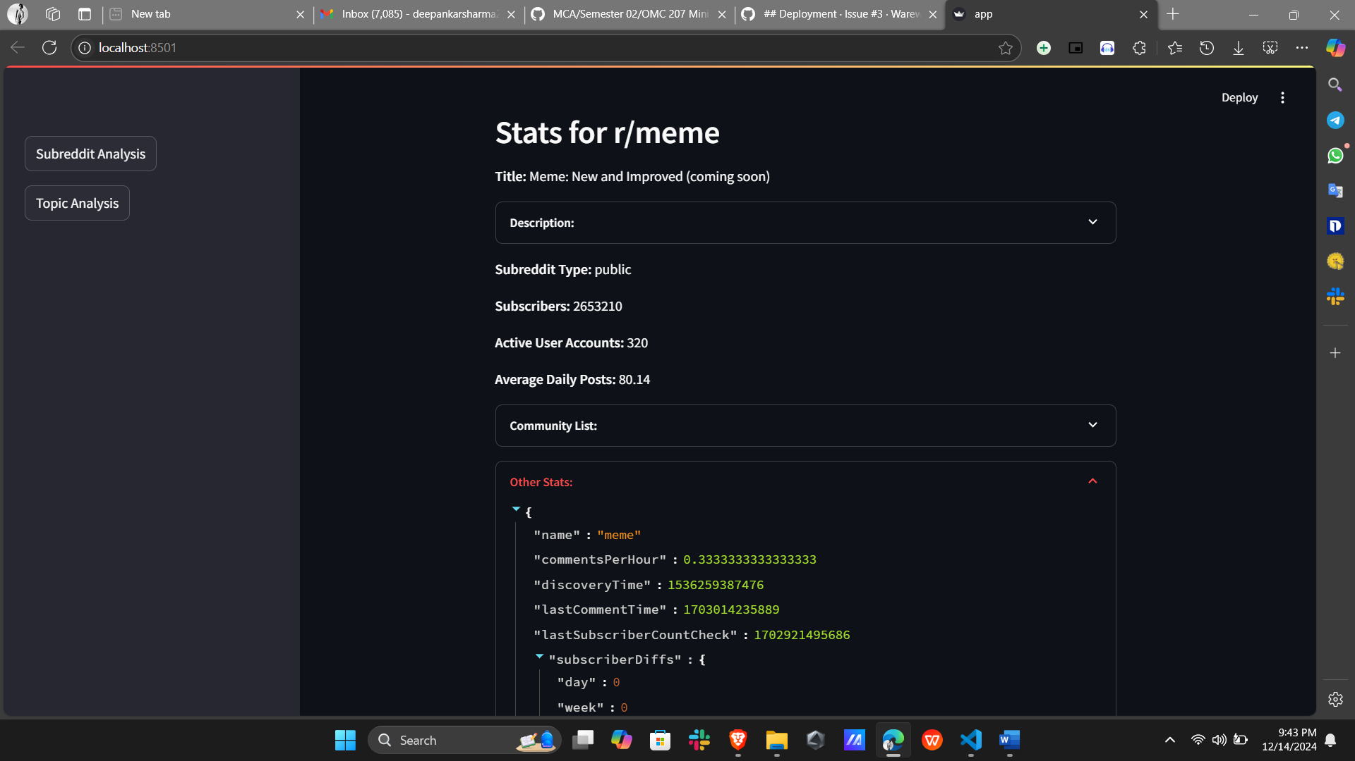

**Dynamic Metric Updates:** By leveraging PRAW, Redzon will continuously pull data on various subreddit metrics such as subscriber counts, post activity, and engagement levels. This capability ensures that users are always accessing the latest information, unlike batch data processing, which can lead to outdated or irrelevant insights.

**Scheduled Data Fetching:** The application will be designed to fetch data at regular intervals or upon user request, ensuring that the information presented is timely and reflects ongoing discussions and trends within the subreddit community.

**Error Handling and Performance Optimization:** The implementation will include robust error handling to manage API request limits and data fetching errors gracefully. Performance optimizations will be considered to ensure that data fetching does not compromise the dashboard’s responsiveness.

3.3 Provide Growth Trend Analysis of Subscribers and Activity Metrics

This objective involves developing analytical tools to assess the growth trends of subreddit subscribers and activity metrics over time. Key components include:

**Subscriber Growth Tracking:** Users will be able to visualize how subscriber counts have changed over specified periods, identifying patterns that may correlate with specific events, content, or community engagement strategies.

**Activity Metrics Analysis:** The tool will analyze various engagement metrics, such as the frequency of posts and comments, to provide users with insights into how active a subreddit is. This information is critical for understanding community dynamics and user participation levels.

**Project Snaps**

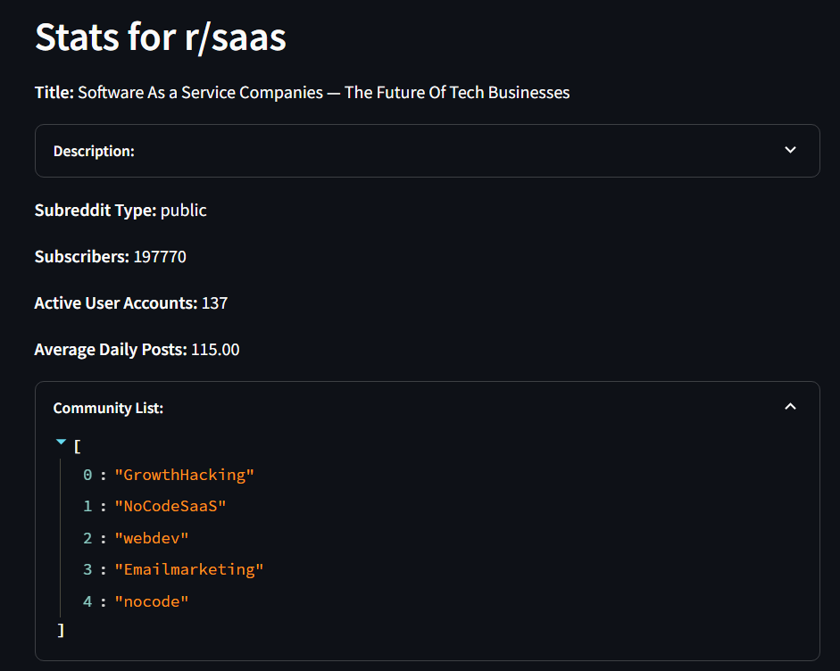

**Visual Representations:** Growth trends will be illustrated using graphs and charts, making it easy for users to interpret the data and draw conclusions about community engagement over time.

The fourth objective is to create a recommendation system that helps users discover related subreddits based on their interests and engagement patterns. This feature will enhance user exploration and community interaction. Key elements include:

**Content-Based Recommendations:** Using algorithms to analyze the content of subreddits, the tool will suggest similar communities based on topics, post types, and user engagement. For instance, if a user is interested in a subreddit focused on "Machine Learning," the system might recommend related subreddits like "Data Science" or "Artificial Intelligence."

**Collaborative Filtering:** The implementation of collaborative filtering techniques will further enhance recommendations by analyzing user interactions and preferences. This method identifies patterns among users with similar interests, providing suggestions that may not be apparent through content analysis alone.

**User Feedback Mechanism:** Users will be able to provide feedback on recommendations, allowing the system to learn and improve over time. This iterative process will ensure that the recommendations remain relevant and personalized.

3.5 Visualize Key Subreddit Data Through Charts and Tables for Intuitive Understanding

A crucial aspect of Redzon is to present data in a visually appealing and easily interpretable manner. This objective emphasizes the development of various visualization tools within the dashboard. Key aspects include:

**Diverse Visualization Techniques:** The application will employ a variety of visualization methods, including bar charts, line graphs, pie charts, and tables, to represent subreddit data effectively. This diversity caters to different user preferences and enhances data comprehension.

|  |  |
| --- | --- |
| 0 | 0 |
| 0 |  |

**Interactive Visualization Components:** Users will be able to interact with visualizations, such as hovering over data points for detailed information or clicking on elements to drill down into more specific data sets. This interactivity will facilitate deeper engagement with the data.

**Dynamic Reports:** Users will have the option to generate downloadable reports that summarize key insights and visualizations, allowing them to share findings with team members or stakeholders easily.

3.6 Optimize Subreddit Data for SEO Applications

The final objective is to optimize subreddit data for applications in search engine optimization (SEO), enabling users to identify trending topics and high-engagement posts. Key components of this objective include:

* **Trending Topic Identification:** The tool will analyze discussion trends within subreddits to identify emerging topics that are gaining traction. This information is invaluable for content creators and marketers looking to align their strategies with current interests.

* **Engagement Metrics for SEO:** Users will have access to metrics such as comment counts, upvotes, and engagement ratios, which can inform their SEO strategies. By understanding what content resonates with audiences, users can create more targeted and effective online content.

* **SEO Strategy Recommendations:** The application will provide users with actionable insights and recommendations based on subreddit data, helping them craft content that aligns with audience interests and search engine algorithms.

**Chapter 4: Hardware and Software Requirements**

To successfully develop and run the "Redzon" application, specific hardware and software configurations are necessary. These requirements ensure optimal performance, efficient data processing, and a smooth user experience. This chapter outlines the hardware specifications needed for development and testing, as well as the software components required to build and deploy the application.

4.1 Hardware Requirements

The hardware specifications for the "Redzon" project focus on providing sufficient computational power, memory, and storage to handle data processing and application performance. The table below lists the essential hardware components:

| **Sl. No** | **Name of the Hardware** | **Specification** |
| --- | --- | --- |
| 1 | Development Machine | Intel i5 Processor, 8 GB RAM, 256 GB SSD |
| 2 | Backup Storage | External HDD with 1 TB capacity |

4.1.1 Development Machine

The development machine is the primary workstation where the application will be built, tested, and debugged. It is equipped with:

* **Intel i5 Processor:** This processor provides a balance between performance and power consumption. It is capable of handling multiple tasks and running complex computations required during data analysis and visualization processes. The i5 processor is suitable for tasks that involve data fetching, processing, and real-time updates, making it ideal for the "Redzon" application.

* **8 GB RAM:** The RAM (Random Access Memory) is crucial for smooth multitasking and efficient data handling. With 8 GB of RAM, the development machine can manage the demands of running the application, performing data analysis, and executing various libraries and tools simultaneously. Adequate RAM ensures that operations such as data fetching from the Reddit API and generating visualizations do not experience significant delays or interruptions.

* **256 GB SSD:** A Solid State Drive (SSD) is preferred over traditional hard drives due to its faster data access and read/write speeds. The 256 GB SSD will provide ample storage for the operating system, application files, and libraries, while also allowing for quick loading times and improved application responsiveness. The SSD will facilitate smooth operations when dealing with large datasets fetched from Reddit.

4.1.2 Backup Storage

To ensure data security and prevent data loss, a reliable backup storage solution is essential. The specifications include:

* **External HDD with 1 TB capacity:** An external Hard Disk Drive (HDD) with a 1 TB capacity will serve as a backup solution for storing project files, application data, and any relevant datasets. This backup storage will allow for regular data backups, safeguarding against hardware failures or accidental deletions. The high capacity provides ample space for multiple iterations of data and project files, ensuring that all critical information is preserved.

4.2 Software Requirements

The software requirements for "Redzon" encompass the operating system, programming languages, libraries, and APIs necessary to build and run the application effectively. The following table summarizes the essential software components:

| **Sl. No** | **Name of the Software** | **Specification** |
| --- | --- | --- |
| 1 | Operating System | Ubuntu 20.04 LTS |
| 2 | Programming Language | Python 3.8 or later |
| 3 | Streamlit | Streamlit 1.3.0 or later |
| 4 | Libraries | PRAW, Matplotlib, Pandas, Plotly |
| 5 | External APIs | Reddit API, PRAW |

4.2.1 Operating System

* **Ubuntu 20.04 LTS:** The chosen operating system for the development environment is Ubuntu 20.04 LTS (Long Term Support). Ubuntu is a popular Linux distribution known for its stability, security, and extensive support for development tools and libraries. The LTS version provides five years of security updates and support, making it a reliable choice for long-term projects. Additionally, many data science and machine learning libraries are well-supported in Linux environments, enhancing compatibility and performance.

4.2.2 Programming Language

* **Python 3.8 or later:** Python is the primary programming language for developing the "Redzon" application. Version 3.8 or later is specified to ensure compatibility with modern libraries and features. Python’s simplicity and readability make it an excellent choice for rapid development, while its vast ecosystem of libraries provides tools for data manipulation, visualization, and API interaction. The flexibility of Python allows developers to quickly implement functionalities required for analyzing subreddit data.

4.2.3 Streamlit

* **Streamlit 1.3.0 or later:** Streamlit is a powerful framework that simplifies the creation of interactive web applications for data science projects. Version 1.3.0 or later will be utilized to leverage the latest features and improvements in performance and usability. Streamlit’s ability to easily convert Python scripts into interactive web applications allows for rapid prototyping and deployment of the "Redzon" dashboard. It provides built-in components for visualizations, user input handling, and dynamic updates, essential for creating a responsive analysis tool.

4.2.4 Libraries

* **PRAW (Python Reddit API Wrapper):** PRAW is a Python library specifically designed for accessing the Reddit API. It simplifies the process of fetching data from Reddit, making it easier to extract subreddit information, posts, comments, and user activity. PRAW handles authentication and provides methods to navigate Reddit’s data structures, allowing developers to focus on data analysis rather than API intricacies.

* **Matplotlib:** Matplotlib is a widely used plotting library for creating static, animated, and interactive visualizations in Python. It will be employed to generate a variety of charts and graphs within the "Redzon" application, enabling users to visualize subreddit metrics effectively.

* **Pandas:** Pandas is a powerful data manipulation and analysis library that provides data structures for efficiently handling structured data. It will be used to preprocess, clean, and analyze the data fetched from Reddit, facilitating operations such as filtering, aggregating, and transforming data into usable formats for visualizations and insights.

* **Plotly:** Plotly is a library for creating interactive visualizations and dashboards. It will complement Matplotlib by providing capabilities for dynamic visualizations that enhance user engagement and interactivity within the application.

4.2.5 External APIs

* **Reddit API:** The Reddit API provides programmatic access to Reddit’s extensive data. It allows developers to extract information from subreddits, including posts, comments, user engagement metrics, and community statistics. The API is the backbone of the "Redzon" application, enabling real-time data retrieval and analysis.

* **PRAW:** As previously mentioned, PRAW acts as a wrapper for the Reddit API, simplifying the process of making API calls and handling data retrieval. It abstracts many of the complexities involved in interacting directly with the Reddit API, allowing developers to focus on building the application's core functionalities.

By adhering to the specified hardware and software requirements, the development team can ensure that "Redzon" is built on a robust foundation that supports efficient data processing, user-friendly interactions, and effective insights generation from Reddit’s rich dataset.

**Chapter 5: Possible Approach/Algorithms**

In this chapter, we will outline the methodologies and algorithms to be implemented in the "Redzon" application. This encompasses data collection, preprocessing, visualization techniques, and analysis methods that will help derive insights from Reddit's vast dataset. Each section will detail the specific approaches and tools used to create a comprehensive and effective analysis tool.

5.1 Data Collection and Preprocessing

5.1.1 API Integration

To initiate the analysis, the first step is to integrate with the Reddit API using the PRAW (Python Reddit API Wrapper) library. This library allows developers to interact with Reddit's API seamlessly, enabling the retrieval of various types of data:

* **Subscriber Counts:** Fetch the number of subscribers for each subreddit, which helps in understanding the audience size and potential reach.
* **Posts:** Collect data on posts made in the subreddit, including titles, content, and timestamps. This information provides insights into community activity and popular discussions.
* **Comments:** Retrieve comments associated with posts to analyze engagement levels and user interactions within the subreddit.
* **Activity Trends:** Gather metrics related to post frequency, comment volume, and other activity trends that can help assess the engagement dynamics over time.

This step is crucial as it establishes the foundation for all subsequent analyses, ensuring that relevant and up-to-date data is used.

5.1.2 Data Cleaning

Once the data is collected, the next step is to clean and preprocess it. This involves addressing various issues that could affect the accuracy of the analysis:

* **Handling Missing Data:** Identify and manage any missing values in the dataset. This could involve removing entries with missing data or filling in gaps with appropriate values, such as averages or median values, depending on the context.
* **Inconsistent Data Entries:** Standardize data formats and correct any inconsistencies. For example, if there are variations in how data is recorded (such as date formats or post types), these need to be normalized for effective analysis.
* **Filtering Outliers:** Analyze the data for outliers that could skew results. Depending on the analysis goals, outliers may be removed or treated to ensure they do not disproportionately influence findings.

Data cleaning is essential to enhance the reliability and validity of the analysis, ensuring that insights derived from the data are based on accurate and consistent information.

5.1.3 Feature Engineering

After cleaning the data, feature engineering is performed to create new variables that can provide additional insights into subreddit performance. This process involves:

* **Engagement Ratios:** Calculate metrics such as the ratio of comments to posts or the average number of upvotes per post. These ratios help evaluate the level of engagement within a subreddit.
* **Trending Keywords:** Use text analysis techniques to extract frequently mentioned keywords from posts and comments. This helps identify the most discussed topics within the community and can guide content strategies.
* **Growth Rates:** Analyze how subscriber counts and engagement metrics change over time to derive growth rates. These rates can indicate how rapidly a subreddit is gaining or losing interest among users.

Feature engineering transforms raw data into more informative variables that can enhance the analysis and provide actionable insights.

5.2 Visualization Techniques

Visualization is a key component of the "Redzon" application, as it helps users interpret complex data more intuitively. The following techniques will be employed:

5.2.1 Time Series Analysis

* **Line Charts:** These will be used to illustrate trends in subscriber counts and activity metrics over time. Time series analysis allows users to visualize how engagement changes, identify seasonal patterns, and detect growth trends in subreddits.

5.2.2 Bar and Pie Charts

* **Bar Charts:** These will represent subreddit rankings based on metrics like subscriber counts or engagement rates. Bar charts are effective for comparing multiple subreddits side by side.
* **Pie Charts:** These will provide a visual representation of the composition of subreddit activity, such as the percentage of total posts made in different categories or topics. While pie charts should be used judiciously, they can be effective for illustrating proportions.

5.2.3 Interactive Dashboards

* **Dynamic Exploration:** Utilizing Streamlit's components, the application will feature interactive dashboards that allow users to filter, sort, and drill down into specific metrics. Users will be able to adjust parameters (like date ranges or subreddit selections) to tailor their analysis to their needs.

Interactive visualizations empower users to explore the data actively, facilitating a deeper understanding of subreddit dynamics and enhancing engagement with the tool.

5.3 Topic and Similarity Analysis

In addition to basic metrics and visualizations, the application will implement more sophisticated analyses to help users discover relevant content and communities.

5.3.1 Keyword Extraction

* **Frequency-Based Techniques:** The application will employ natural language processing techniques to analyze post and comment text. By calculating the frequency of words and phrases, the tool can identify trending topics and keywords that resonate with users. This helps in understanding what drives engagement in different subreddits.

5.3.2 Community Clustering

* **Identifying Similar Subreddits:** By analyzing the content and user overlap between subreddits, the application will be able to cluster communities that share similar interests. Techniques like cosine similarity or Jaccard index can be used to quantify similarity based on user interactions and shared content.

Community clustering facilitates the discovery of related subreddits, enabling users to expand their engagement and explore new areas of interest within Reddit. This feature can be particularly beneficial for content creators and marketers looking to reach targeted audiences.

**Chapter 6: Applications and Real-World Impact**

The "Redzon" application has a wide range of applications across various domains, enabling businesses, marketers, community managers, and researchers to leverage Reddit's extensive data for informed decision-making and strategic initiatives. Here, we explore several key applications and the real-world impact of using the insights generated by this tool.

1. SEO and Organic Traffic Optimization

One of the primary applications of "Redzon" is in the realm of search engine optimization (SEO) and organic traffic enhancement. Businesses can utilize the insights gained from analyzing subreddit data to identify trending subreddits and topics relevant to their industry or niche. By focusing on these insights, they can:

* **Optimize Content Strategies:** Marketers can create content that aligns with the interests and discussions happening in high-traffic subreddits, thus increasing the likelihood of engagement and shares. This approach ensures that the content resonates with the target audience, improving its chances of ranking higher in search engines.

* **Keyword Targeting:** By analyzing trending keywords and topics derived from subreddit discussions, businesses can refine their SEO strategies to incorporate these keywords into their content. This helps attract more organic traffic from search engines and social media platforms.

* **Competitive Analysis:** By monitoring competitors’ activity in relevant subreddits, businesses can identify gaps in their own content strategies and capitalize on opportunities to differentiate themselves in the market.

2. Content Marketing

The "Redzon" application serves as a powerful tool for content marketers aiming to maximize their return on investment (ROI) from campaigns. Through its comprehensive analysis features, marketers can:

* **Target High-Engagement Communities:** By identifying subreddits with high levels of engagement, marketers can direct their campaigns toward these communities, enhancing their outreach efforts. Targeting active subreddits increases the likelihood of content being seen, shared, and engaged with by the audience.

* **Campaign Performance Tracking:** The application provides the ability to monitor how specific content performs in various subreddits, allowing marketers to assess the effectiveness of their campaigns in real time. This enables quick adjustments and optimizations based on audience responses.

* **Influencer Identification:** By analyzing user engagement within subreddits, marketers can identify influential community members or content creators who can help amplify their message. Engaging with these influencers can further enhance brand visibility and credibility within the community.

3. Community Management

Subreddit moderators and community managers can benefit significantly from the analytics provided by "Redzon." The tool enables them to:

* **Track Activity Trends:** Moderators can monitor the frequency and volume of posts and comments over time, gaining insights into community engagement levels. This information helps them understand when the community is most active and what topics generate the most discussion.

* **Engagement Metrics Analysis:** By assessing engagement metrics, moderators can identify which types of posts (e.g., images, links, or text) resonate best with their audience. This knowledge can guide content creation and moderation strategies to enhance community participation.

* **Conflict Resolution:** Analyzing comments and interactions can help moderators identify potential conflicts or negative trends within the community. By addressing these issues proactively, they can foster a healthier and more engaged environment.

4. Trend Analysis

Researchers and analysts can leverage "Redzon" for in-depth trend analysis, which is particularly valuable for understanding cultural shifts and audience behavior. The application allows them to:

* **Predict Future Activity:** By examining historical data and trends, researchers can develop predictive models to forecast future subreddit activity. This can be particularly useful for anticipating shifts in public opinion or emerging interests within specific communities.

* **Identify Emerging Subreddits:** The tool can help researchers spot new and rising subreddits that are gaining traction. Understanding these emerging communities provides insights into changing interests and can inform content strategies or product development.

* **Social Research:** By analyzing discussions within subreddits, researchers can gain insights into societal trends, opinions, and behaviors. This qualitative data can be invaluable for studies related to sociology, marketing, and consumer behavior.

**Chapter 7: References**

To support the development and functionality of "Redzon," several documentation and resources have been referenced. These resources provide valuable information on the technologies and libraries utilized in the application:

1. **Reddit API Documentation:** This resource offers comprehensive guidelines on how to interact with the Reddit API, including endpoints, authentication methods, and data formats.  
   [Reddit API Documentation](https://www.reddit.com/dev/api/)
2. **PRAW Documentation:** PRAW (Python Reddit API Wrapper) simplifies the integration of Reddit data into Python applications, making it easier for developers to access and manipulate Reddit content programmatically.  
   [PRAW Documentation](https://praw.readthedocs.io/en/stable/)
3. **Streamlit Documentation:** This documentation provides insights into how to build interactive web applications using Streamlit, focusing on real-time data visualization and user engagement.  
   [Streamlit Documentation](https://docs.streamlit.io/)
4. **Matplotlib Library:** Matplotlib is a comprehensive library for creating static, animated, and interactive visualizations in Python. Its documentation offers examples and guidelines for effective data visualization.  
   [Matplotlib Library](https://matplotlib.org/)
5. **Pandas Library:** Pandas is a powerful data manipulation and analysis library for Python, essential for data cleaning and preprocessing tasks. The documentation includes tutorials and examples to facilitate its use.  
   [Pandas Library](https://pandas.pydata.org/)